Name _____________________________________ Class: _______ Date: ___/___/___

**Inductive Reactance**

**Assignment # 5- Solve Time Constant Problems**

1. The graph shows which of the following values in a series RL, DC circuit (check the correct statements).

____ a. current increase on curve B

____ b. current increase on curve A

____ c. current decrease on curve B

____ d. current decrease on curve A

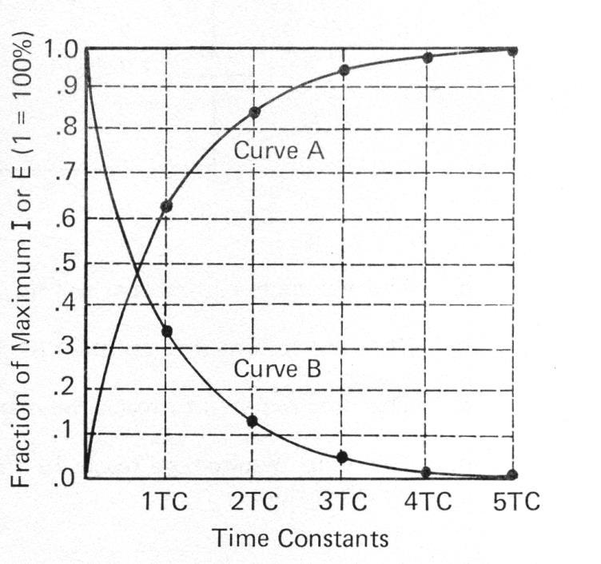

1. Refer to the chart. How many time constants are required for

____ a. Current rise to maximum value?

1. Refer to Curve A only in the chart. At 1 TC, what is the percentage of current increase?

___________________________.

1. What is the percentage of current increase at 2 TC? _____________________.
2. What is the percentage of rise at 3 TC? ____________ 4 TC? ___________.
3. In effect, when the switch is turned off and current starts to decay, it will have dropped to what percentage of its maximum value at 1TC (the first percentage on the B curve)?

_______________________.

1. What is the percentage decay at 2 TC? _______________ 3 TC? ______________

8. Using the following circuit and the universal time constant chart, answer the questions

below the circuit. (Use the space below to show your formulas)

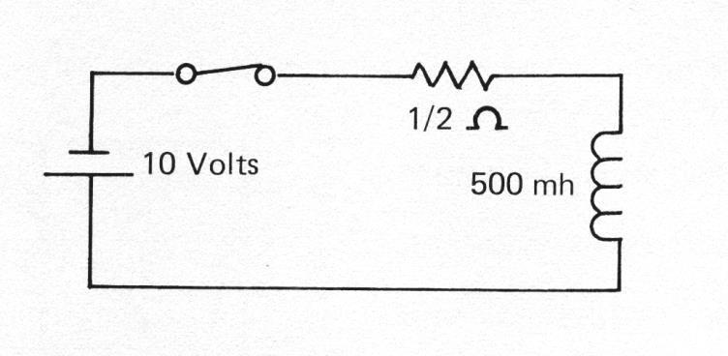

1. The maximum current that will flow in the circuit is ____________ amps.
2. The time for one-time constant is _____________________________________.
3. The time required to reach the maximum current after switch closure is _______.
4. The time required to reach 19 amperes is _________________ seconds after switch closure.