Name______________________________________Class:_________________Date:____/____/____

Inductance

Assignment # 3

- Which pair of coils has the greatest mutual inductance (A) or (B)? (Assume everything except the spacing to be identical.)
A_____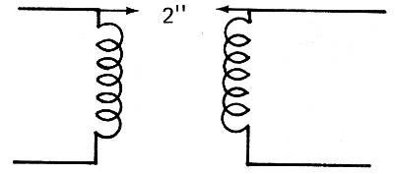 B_____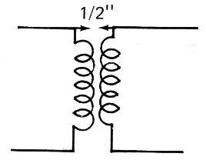

- In Problem one, is the coil with the greatest coefficient of coupling (A) or (B)? __________

- The coefficient of coupling between two coils is found to be 0.2. If the coils both have 4mh of inductance, the mutual inductance is
A. ___________________________________________.
(HINT: L_{M} = k √ )

- If the coils are connected in series and the inductance is aiding, the total inductance is__________________________________________.

- If the coils are connected in series and the inductance is opposing, the total inductance is__________________________________________.

