Using a Microscope – note
Objective 1: Identify the parts of a microscope
Information | Delivery Methods
- Arm  The basic frame, used to CARRY the microscope.  - BASE  The bottom stand, which houses the LIGHT.  - Body  Contains MIRRORS to reflect light to the eyepiece.  - COARSE Adjustment  Roughly focuses the image by bringing the specimen and objective lenses closer together or farther apart.  - Diaphragm  A disc-shaped device, located beneath the stage, used to control the AMOUNT of LIGHT passing through the specimen.  - Eyepiece  The UPPER lens, nearest your eye, which magnifies the image already magnified by the objective and brings the light rays to a focus at the eye.  - FINE ADJUSTMENT  SHARPENS the image of the specimen, by moving the specimen and objective lenses very small distances closer together or farther apart.  - Light  The SOURCE of the light which passes through the specimen.  - Nosepiece  The REVOLVING part that supports three objectives with different magnifications.  - Objective  The lenses closest to the specimen that MAGNIFIES the image of the specimen.  - STAGE  The flat table-like AREA where the slide or specimen is placed.  - Stage Clips  HOLDS the slide on the stage, to prevent it from slipping around. | Allow students to learn the parts of the microscope from Slides 8-33 and have them capture the information in their notes.
Practice parts of the microscope  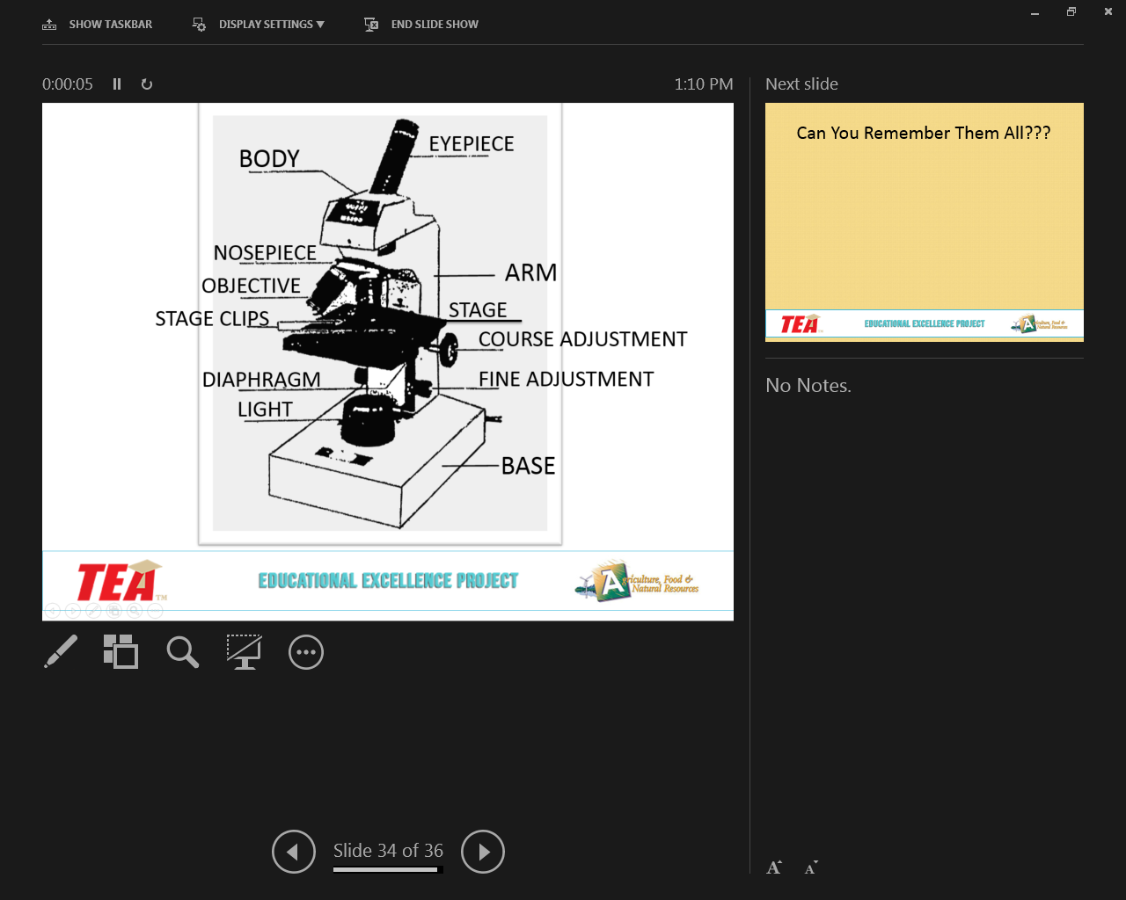 | Show the microscope without terms on slide 36 and have students recall the parts from memory.

Objective 2: List and define common microscope terms
- Slide  A piece of GLASS upon which the specimen is placed for viewing.  - Cover Slip  A thin SQUARE piece of glass or plastic used to COVER the specimen.  - High power  The high-power objective on the nosepiece (usually 40x).  - Medium power  The middle power objective on the nosepiece (usually 10x).  - Low power  The lowest power objective on the nosepiece (usually 4x).  - Magnification  The number of TIMES an object apparent size is INCREASED by the lens system.  - The total magnification of the lens system is determined by MULTIPLYING the power of the objective times the power of the eyepiece (usually 10x).  - Resolution  The ability of the lens system to distinguish and SEPARATE fine details in a specimen.  - Field of view  The AREA of the specimen which is seen through the lens system. The bright circle you see when considering a microscope.  - Depth of field  The ability of a lens system to furnish a distinct image ABOVE and BELOW the focal plane. Depth of focus decreases with the increase of magnification.  - Parfocal  When the objective is in focus, it can be SWITCHED from one power to another, with only small fine focus adjustments being necessary. | Have students follow along in their note packets and capture relevant information as you discuss the terms.  Give students some practice in calculating magnification. For example, ask them if the eyepiece was 10x and the low power (4x) objective was in place, how many times would the object you were viewing be magnified (40x). Tell them this is a basic math concept that they are putting to practical use!

Objective 3: List common safety and handling procedures for using microscopes
- Use of the Microscope  - 1. Carry with BOTH hands.  - 2. Set the microscope in from the EDGE of the desk.  - Use of the Microscope  - 3. Use lens paper to CLEAN eyepiece and objectives.  - 4. START with the LOW power (shortest objective) in place.  - Use of the Microscope  - 5. Turn the coarse adjustment so that the STAGE is as close to the low power as possible -- now while looking, turn the coarse adjustment so the stage starts to move away from the objective.  - 6. CLEAN up all spills and moisture from stage before putting away.  - Use of the Microscope  - 7. Caution -- keep all WATER away from electrical parts  - 8. Never use the COARSE adjustment with the HIGH-power objective while trying to focus, because of the danger of striking and breaking the glass slide with the objective. | Have students follow along in their note packets and capture relevant information as you discuss the terms  Stress the importance of treating the microscopes with care and explain that only one drop can destroy the machine (and they are expensive).

Objective 4: Demonstrate the ability to properly focus, change magnification, and adjust field of vision in a microscope
DRAWINGS OF THE LETTER "e"  1. Cut a lower-case letter "e" from the smallest print of a newspaper.  2. Place the cut letter "e" on a slide.  3. Add one drop of water on the "e".  4. Place a cover slips over the drop of water.  Observations:  - Draw the "e" in the space provided, as it looks when seen with the naked eye. Make sure that size and position are accurately shown in your drawing.  - Draw the "e" in the space provided, as you see it under the low power objective of your microscope. The size and position of the "e" should be accurate.  - Record the change in size and position of the "e" as seen under low power of the microscope as compared with the position seen with the naked eye.  - Move the slide in each of the directions indicated below. Record your results.  - to the right  - toward you  - to the left  - away from you  - Adjust the diaphragm to produce various degrees of light intensity. Record the changes you see in the texture of the letter "e".  - Note: As you develop skill in using the microscope, you will find that light regulation is important in seeing the details of an object.  - Draw the "e" in the spaces provided, as seen under both the medium and high-power objectives.  How much of the "e" is seen now, as compared to the view under low power?  THREADS  1. Cut a piece of red thread 3 cm. long.  2. Cut a piece of gold thread 3 cm. long.  3. Place the threads on a slide to form an "X".  4. Cover the "X" with a piece of tape.  Observations:  - While looking through the eyepiece move the slide until the thread "X" comes into view. Make some observations using medium power. Record a description of what a thread is really like?  - Change to high power.  - Use the fine adjustment to focus up and down on the threads where they cross. Can you tell which is on top?  - Move the fine adjustment so that the top thread is in focus. Using colored pencils, draw the field of view in the space provided. Why do only parts of the thread appear sharp and clear at any given time?  - Move the fine adjustment, so that the bottom thread is in focus. Using colored pencils, draw the field of view in the space provided.  - Observe the thread carefully, as you slowly change the diaphragm settings. Record the differences you see under the various settings.  - Description of thread as seen under the microscope. | Students will complete the assignment as listed on the lab sheet using the microscopes  Make sure you are walking around to facilitate and help troubleshoot problems in focusing the microscopes.

