Name_______________________________________ Date_______________________________

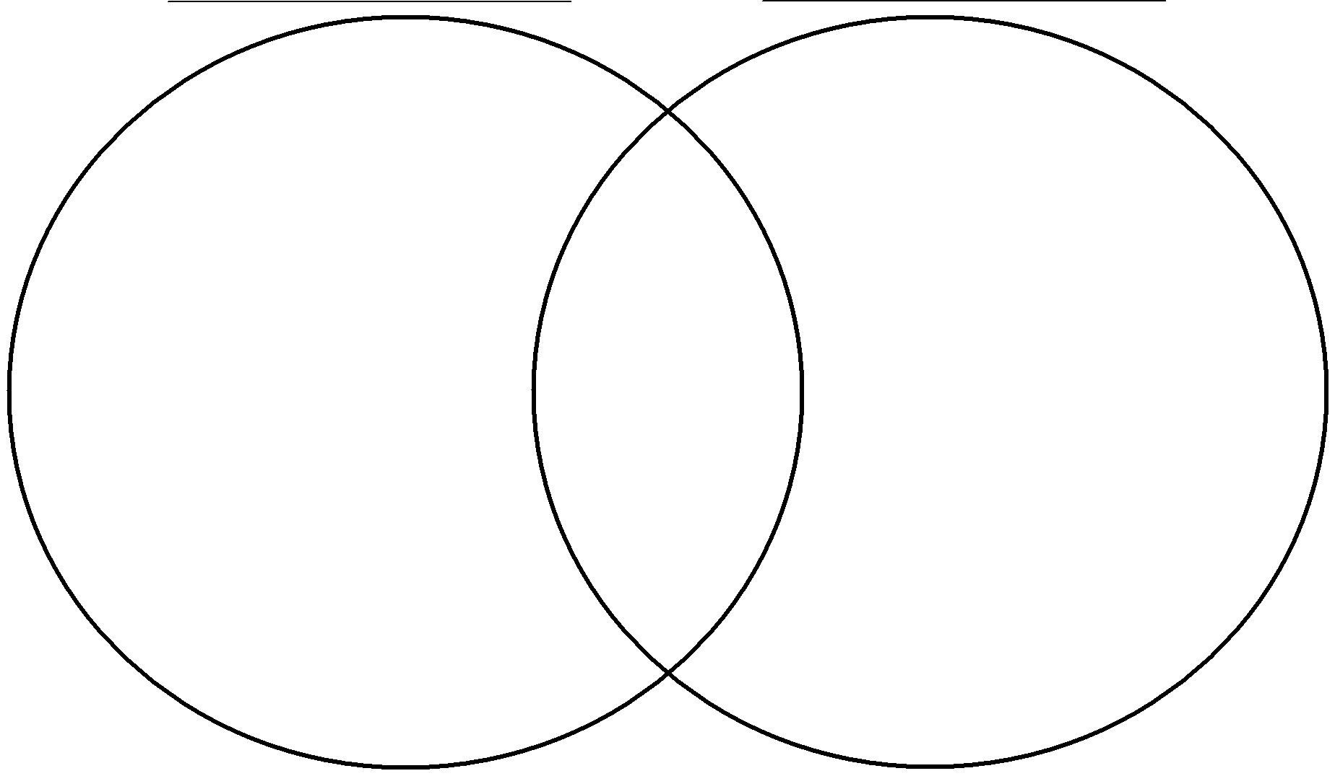**Venn Diagram**